**CHAPTER 1**

**INTRODUCTION**

**1.1 INTRODUCTION OF PROJECT:**

This beginners project is platform for underrated talent come in shine, which is under the hat of brands. Free platform for buying and selling products. Nowadays most of the purchasing of the items that are needed for the daily basis, can be got through the online mode. The Online Shopping is a web-based application intended for online retailers. The objective of this application is to make it interactive and its ease of use. It would make searching, viewing and selection of a product easier.

In other words, the project aimed at creating a virtual shop environment for users, in some handy form, which will be available to them through the internet. Although the idea of developing online shopping websites is not new in the electronic market and has been evolved soon after the World Wide Web(www).

**1.2 PROBLEM STATEMENT:**

The Art and talent of poor people is crushed under the big brands. Due to the lack of economic and business knowledge those people got behind from big brands as use high business strategies and they invest huge amount on marketing

To overcome these problems, we have created a solution. Due to pandemic and use to easy lifestyle now a days lots of people prefer online shopping frequently and on huge scale with the help of the Internet we connected more and more people together and also.

we provided them one platform where they can promote their products worldwide, we have specifically designed this web site for the poor people to promote their products and brand This online shopping system is designed to meet people's arts objects, decorative shopping needs.

In this web site we also conducted some charity and special schemes to help needy people by all heart and soul.

**1.3 OBJECTIVES:**

The main objective of this project is to promote underrated people’s art and talent. And to manage details of shopping, internet, payment, bills, costumer. It manages all the information about shopping, products, costumer. The purpose of project is to build a website to reduce manual work for managing shopping, so that the poor people can sell their products, arts without any bargaining. It tracks all details of payments, bills and costumers.

**1.4 SCOPE OF THE PROJECT WORK:**

Scope of the project is to bring Art and Talent of poor people in public eye. And to promote their products. Purchasing and selling products and services over the internet without the need of going physically to the market is what online shopping all about. Online shopping is just like a retail store shopping that we do by going to the market, but it is done through the internet. Online shopping has made shopping painless and add more fun.

Our designed online shopping system provides a 24×7 service, that is customers can surf the website, place orders anytime they wish to. Also, the delivery system works 24×7 hours a week. Some of the features that can be modified and added to this system in the future involve its implementation by local shopkeepers, where shops will be providing an online interface to customers for shopping and placing orders.

Then some delivery persons can perform their work. This will be adding on benefit for the customers as it will save their time, plus it adds on for the shopkeepers also, as people will continue to shop from local shops rather than preferring to supermarkets every time

**1.5 RESEARCH METHODOLOGY:**

There was a strong foundation for pursuing this project as it aimed to provide a greater understanding of the consumer and the motivations behind online shopping. As the importance of the online channel becomes increasingly greater for organizations, there is greater need for determining the consumers’ key drivers in choosing this as an alternative channel for shopping. The project results impact both consumers and organizations. For consumers, this gave them a venue for stating their preferences and key requirements to continue using the online channel which could lead to improvements on the online shopping experience. For organizations, this project provided an understanding of the current situation and also the emerging trends based on competitive dynamics, in order to be able to provide the consumers their requirements.

**1.6 LIMITATION OF STUDY:**

* Lack of shopping experience
* Delay in delivery
* Warranty issues
* Lack of security
* Lack of feel and touch
* Hidden cost
* Digital payment failures
* Additional charges
* Quality issues
* Lack of after sales service

**1.7 EXPECTED OUTCOME:**

Underrated talent come in shine, which is under the hat of brands. Free platform for buying and selling products. To bring Art and Talent of poor people in public eye. And to promote their products. Purchasing and selling products and services over the internet without the need of going physically to the market.

**CHAPTER 2**

**LITERATURE REVIEW**

This beginners project is platform for underrated talent come in shine, which is under the hat of brands. Free platform for buying and selling products. Nowadays most of the purchasing of the items that are needed for the daily basis, can be got through the online mode. The Online Shopping is a web-based application intended for online retailers. The objective of this application is to make it interactive and its ease of use. It would make searching, viewing and selection of a product easier.

This chapter will mainly discuss on the study that are done by previous research of other authors in the similar area of the present study. Throughout this chapter, there will be comprehensive discussion on theoretical and practical views of previous studies done in online shopping and offline shopping for apparels. This study combines factors that other studies have done that will influence the consumer’s purchasing decision in online and offline stores for apparels. It includes the price attractiveness, time saving, perceived risk, enjoyment and excitement, tangibility and high interactivity. All of these factors will contribute to the study of customer’s purchasing intention for apparels on both stores which includes online and offline shopping.

**CHAPTER 3**

**ELEMENT CHART FOR COMPLETION OF PROJECT**

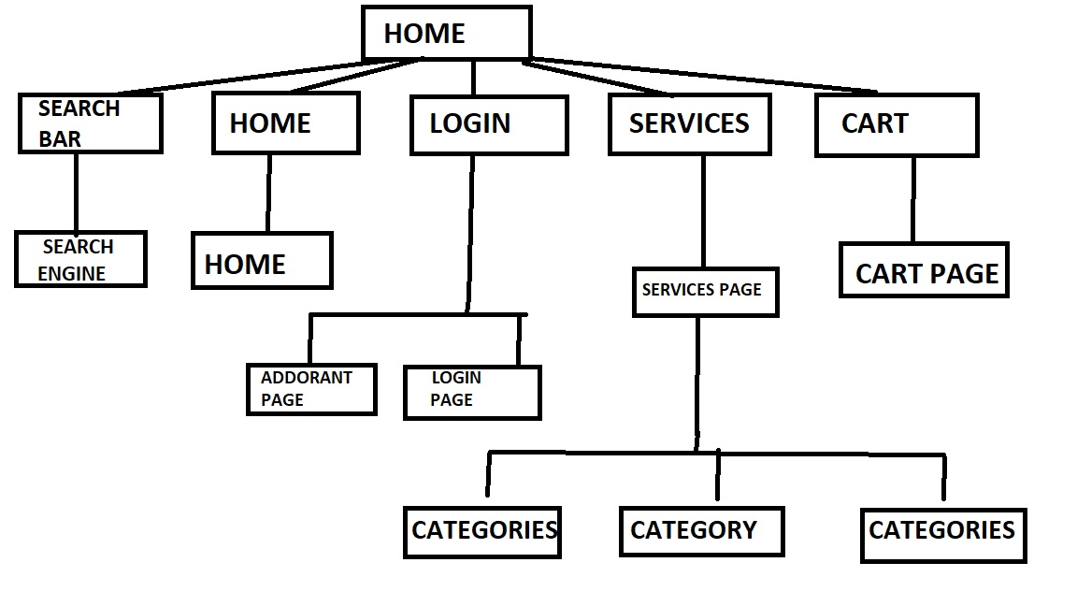

**Fig.3.1:-Element chart**

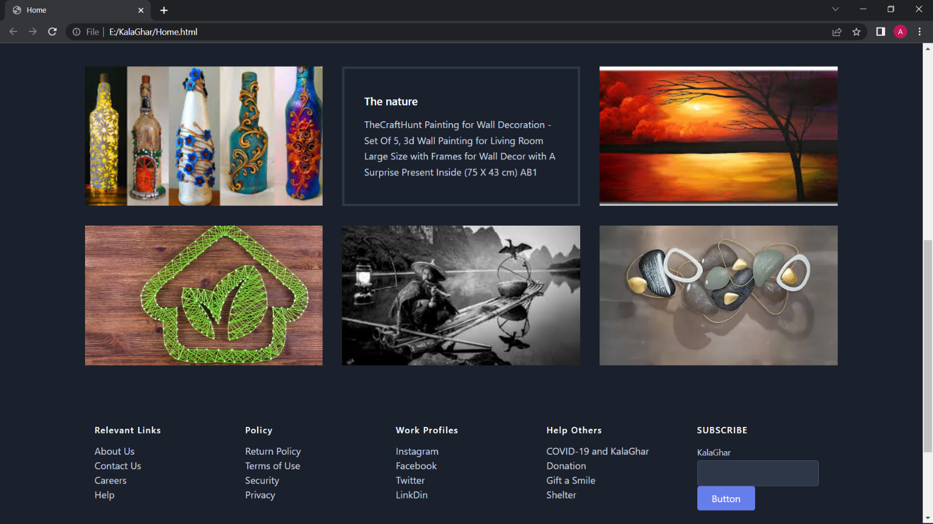

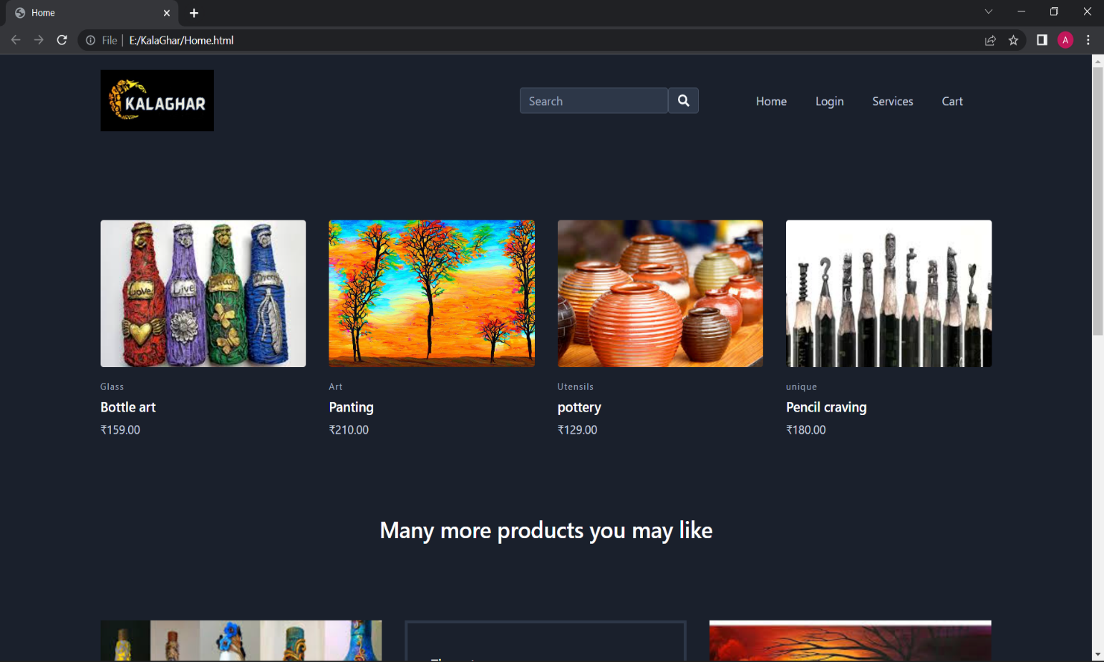

**Fig.3.2: - home page**

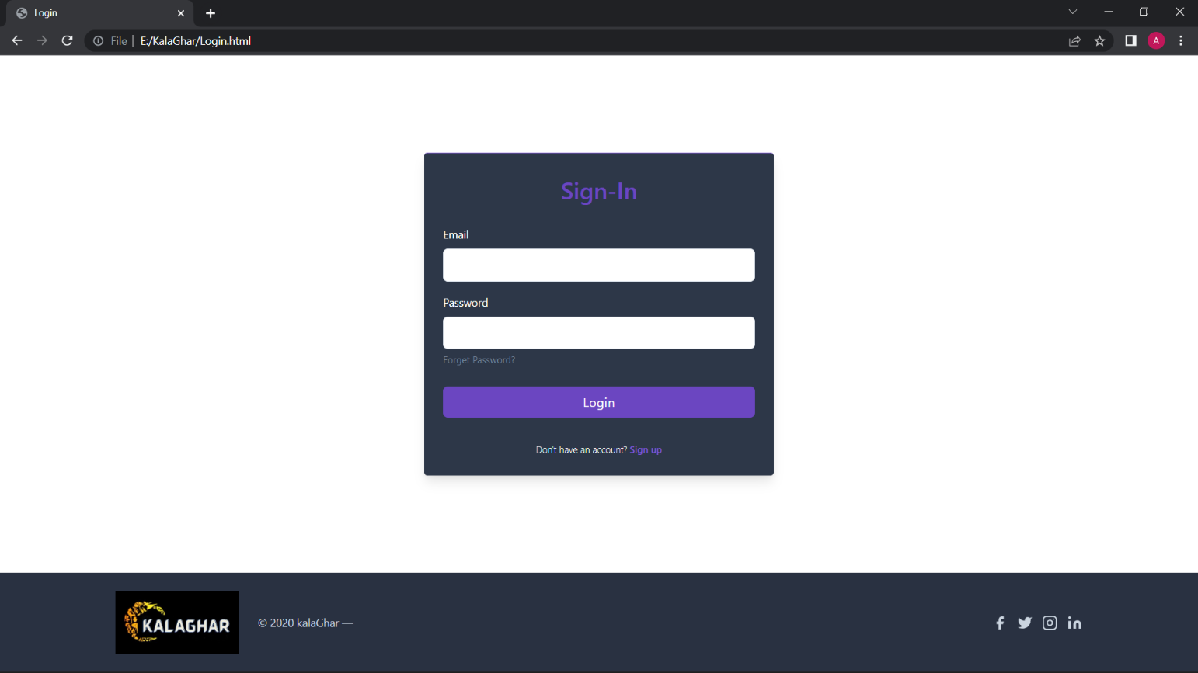

**Fig.3.3: -login page**

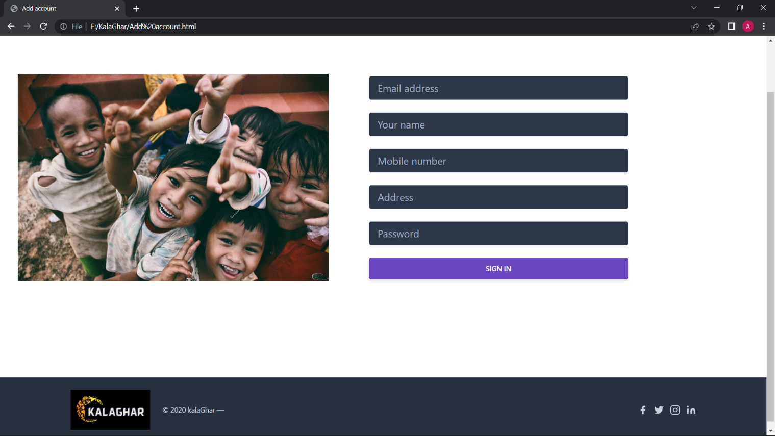**Fig.3.4: - Add account page**

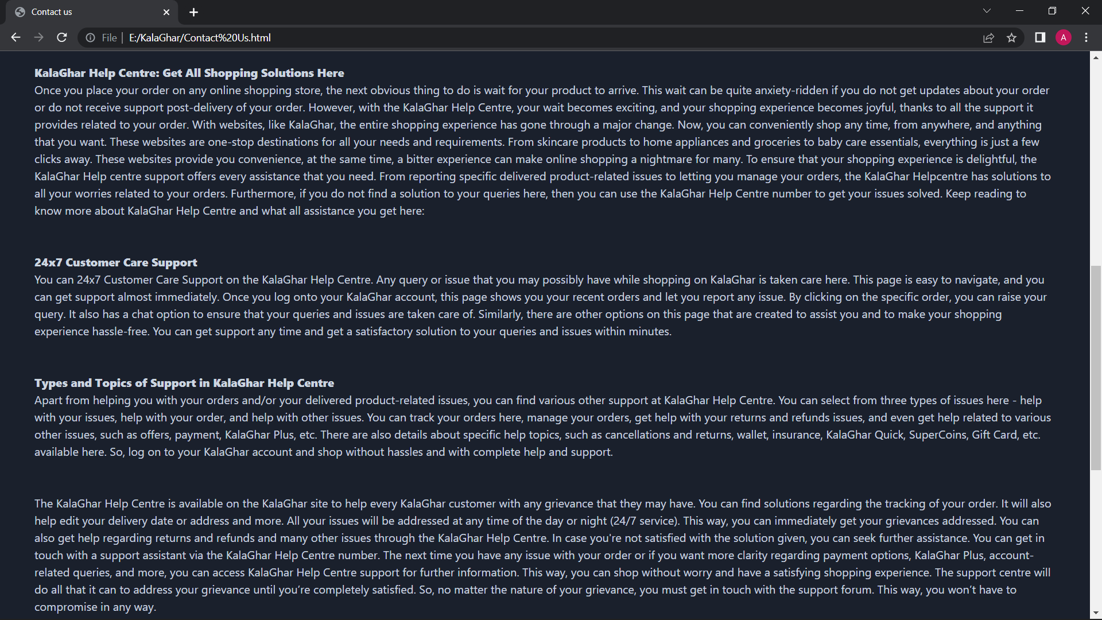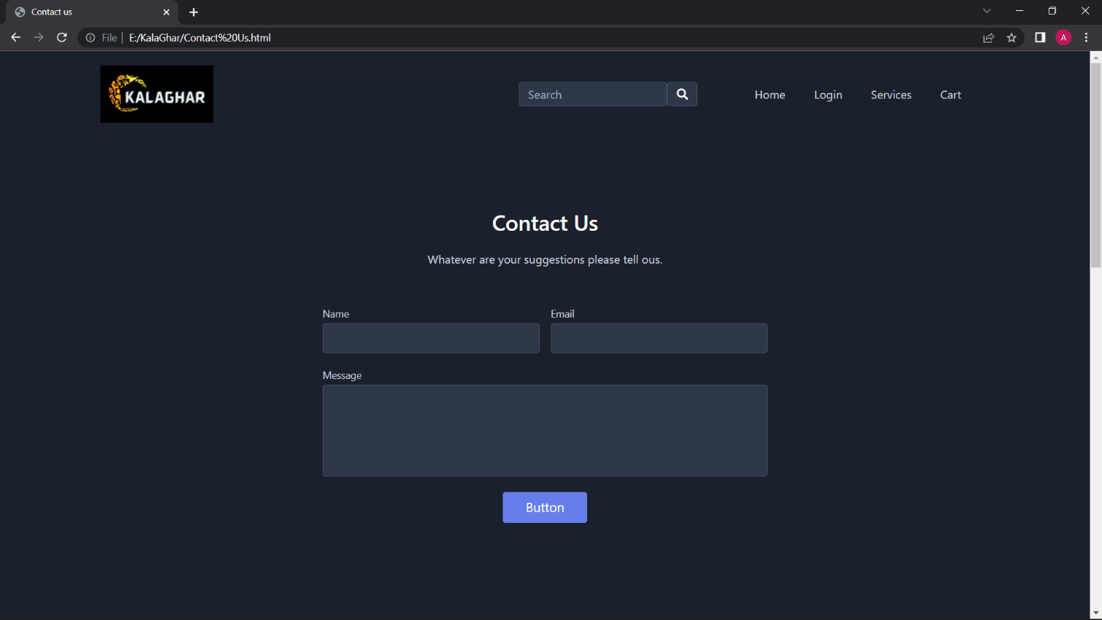

**Fig.3.5: - contact us page**

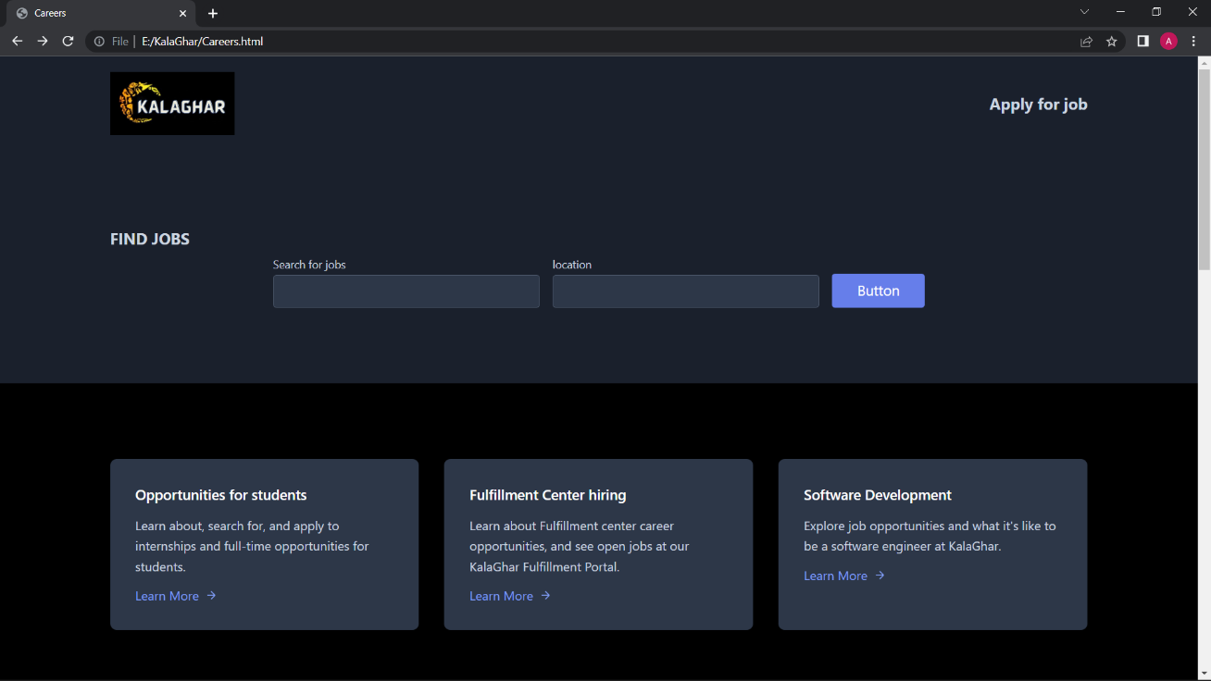

**Fig.3.6.: -careers page**

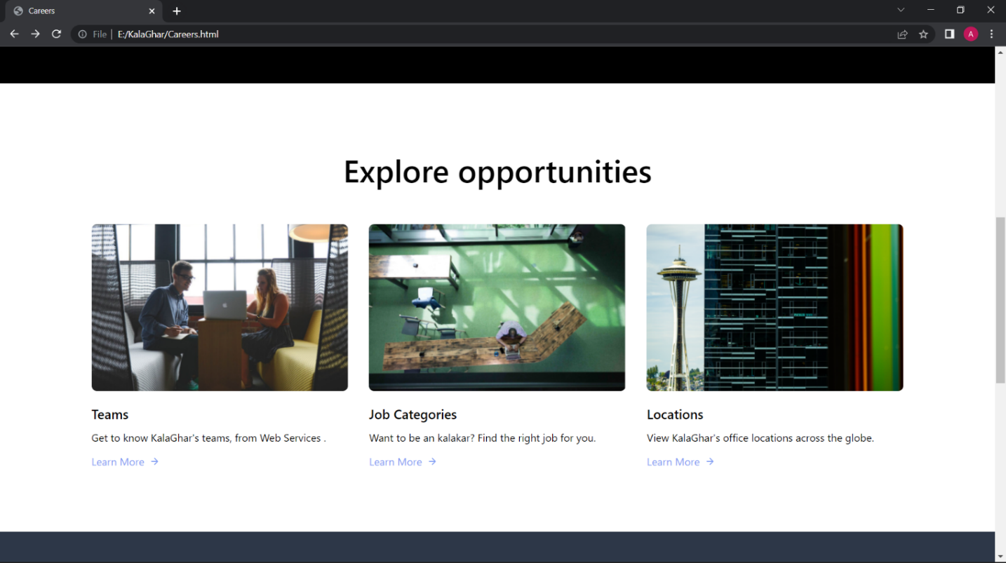

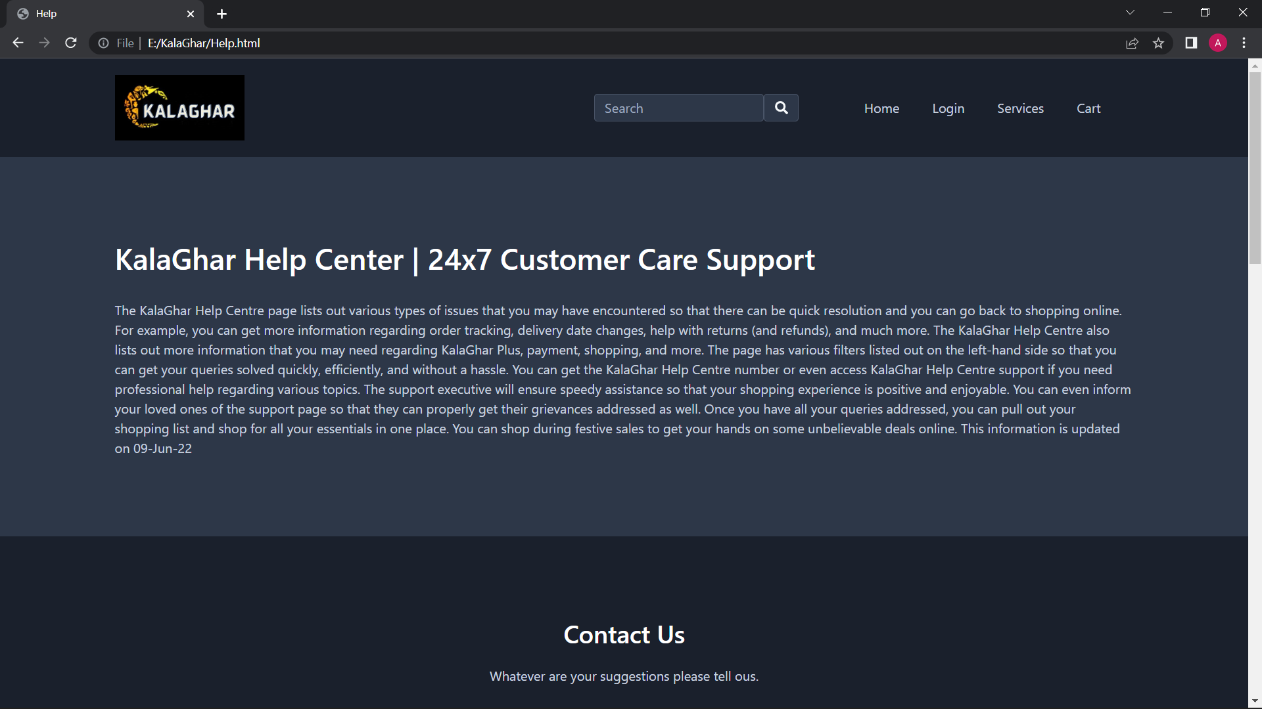**Fig.3.7: - Customer care support page**

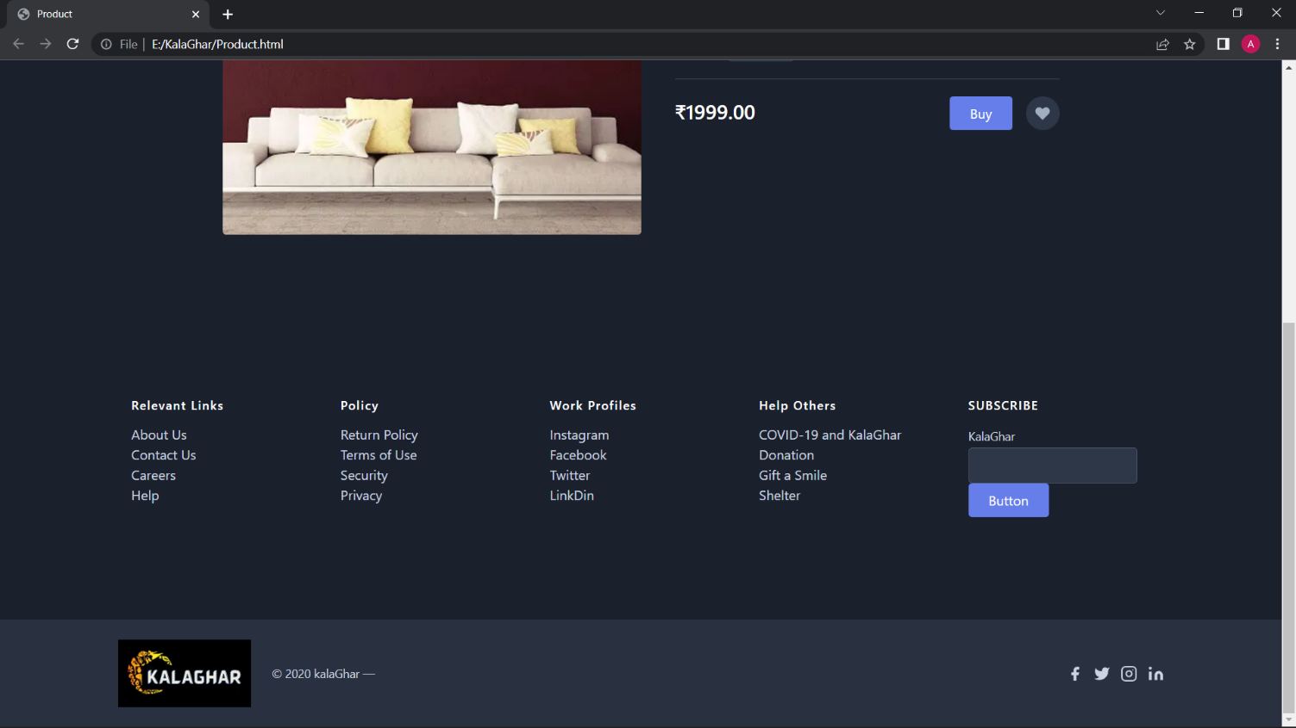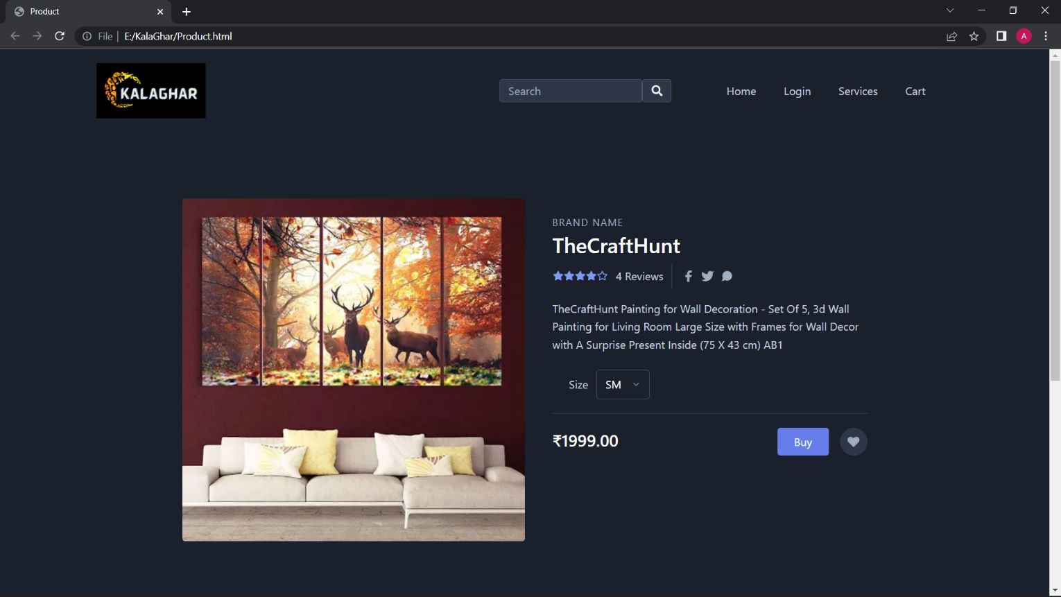**Fig.3.8: - Commercial page**

**CHAPTER 4**

**CONCLUSION**

Our project is only a humble venture to satisfy the needs of poor people to manage their work. Several user-friendly coding has also been adopted this package shall proof to be a powerful package and satisfying all the requirements of the needy ones and to provide them a platform. The objective of software planning is to provide a framework that enables to make reasonable estimates made within a limited timeframe. The more you give to poor and needy people, the more you strengthen their dependency. Our model also encouraged the needy ones to interchange their own ideas according to their interest. Their activities encourage them and also helps to improve their financial condition. We also conduct a survey comparing their performance and growth using our proposed model. As a result, we have to develop various ways to motivate them an encourage them towards their work. Currently we are refining our earlierwork and hence our website proves to be helpful to the poor people.

**CHAPTER 5**

**REFERENCES**

* [**www.flipkart.com**](http://www.flipkart.com)
* [**www.amazon.com**](http://www.amazon.com)
* [**www.Stackflow.com**](http://www.Stackflow.com)
* [**www.coder.com**](http://www.coder.com)
* [**www.github.com**](http://www.github.com)
* **www.w3school.com**